Python groupwork
Group members:
- CYUBAHIRO Olivier
- IGIZENEZA Prince
- ISHIMWE Hertier
How we installed and tested PYTHON
Installation of python

- We Opened our chrome and navigated to the official site
- We opened google and typed “python download”
- And we clicked on the link from python.org
- Then we downloaded python.
- On its home page, we clicked on the button like “download python 3.13.7(64 bits)”
- We waited for download to finish.
- Running the installer.
  - We opened our downloads folder.
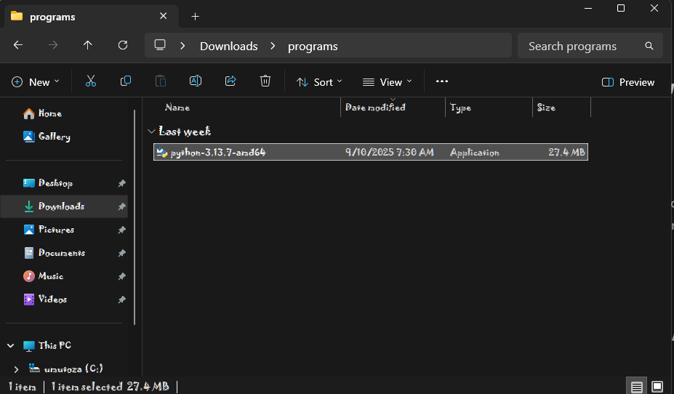
  - We double clicked on our downloaded file
  - When the setup windows opened
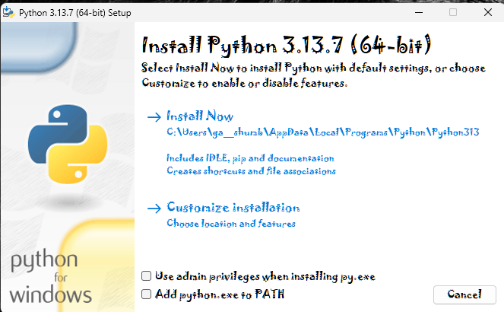
- We made sure the above boxes were all ticked
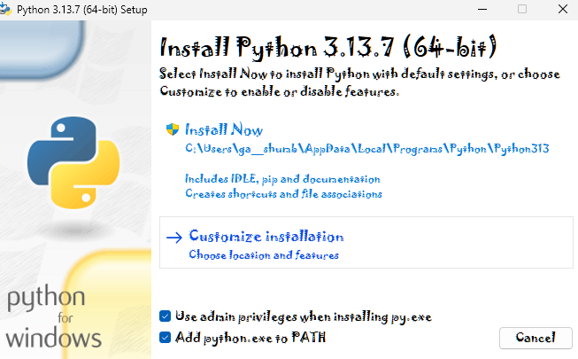
- Then we clicked install now.
- Wait for the setup to finish.
- It took a few minutes.
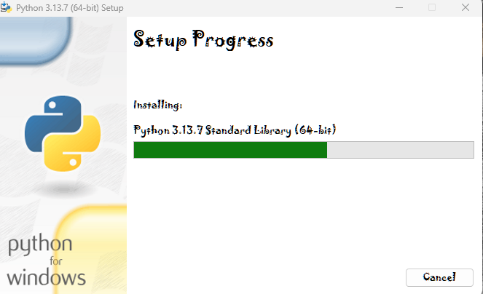
- When the setup was done. We pressed close
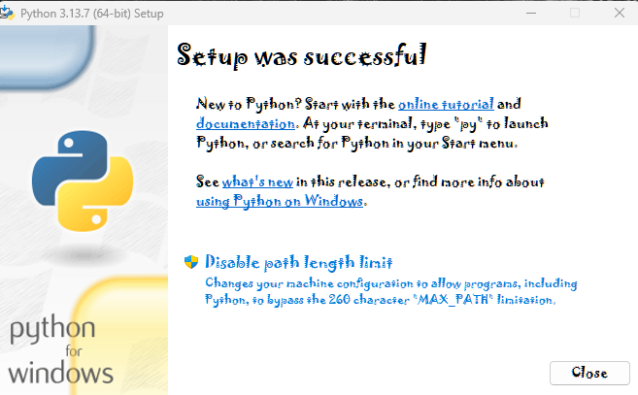

TESTING PYTHON
- WE CHECKED IF OUR PYTHON WAS WORKING
- We pressed windows key + R, and typed CMD then Enter.
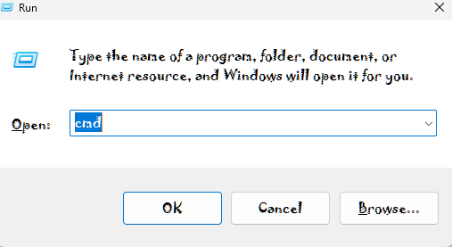
- In the black windows that opened we typed:
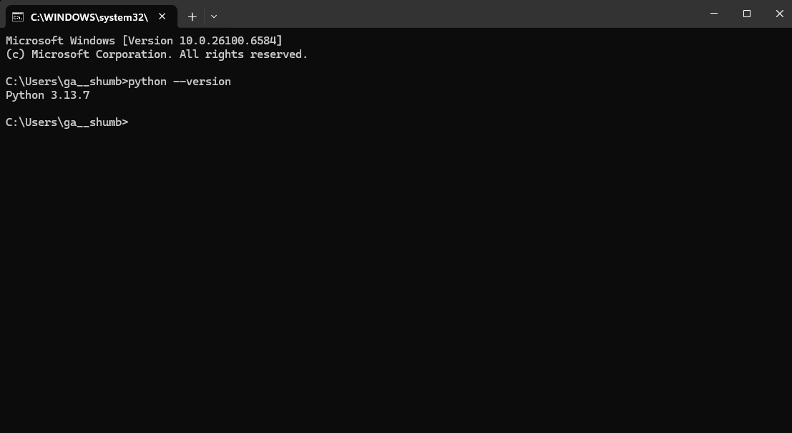
- If it shows your python version then your python is well installed.
- Testing our python.
- In that same windows, we typed:
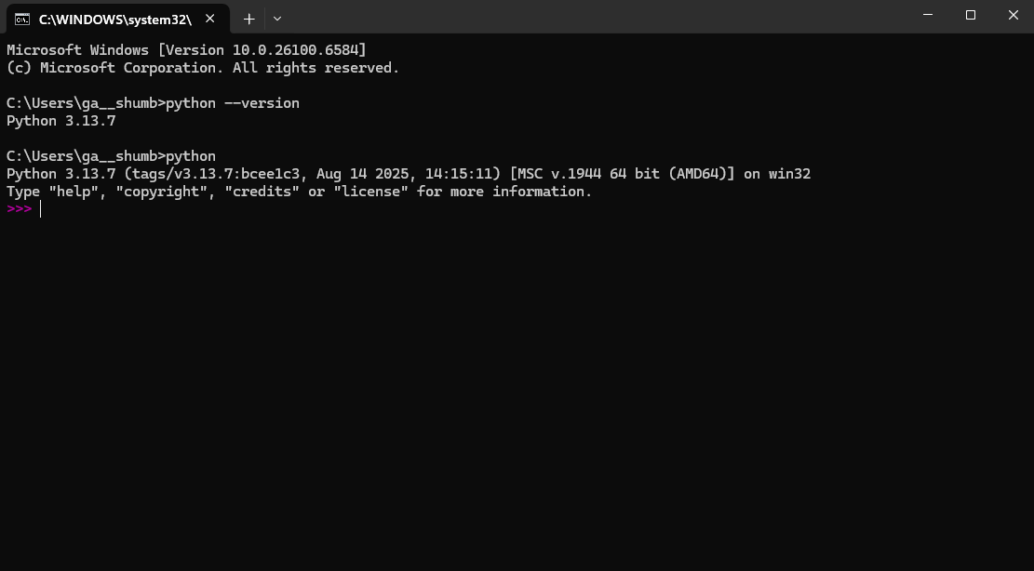
- We tried printing a name to see if it runs well and this was the results:
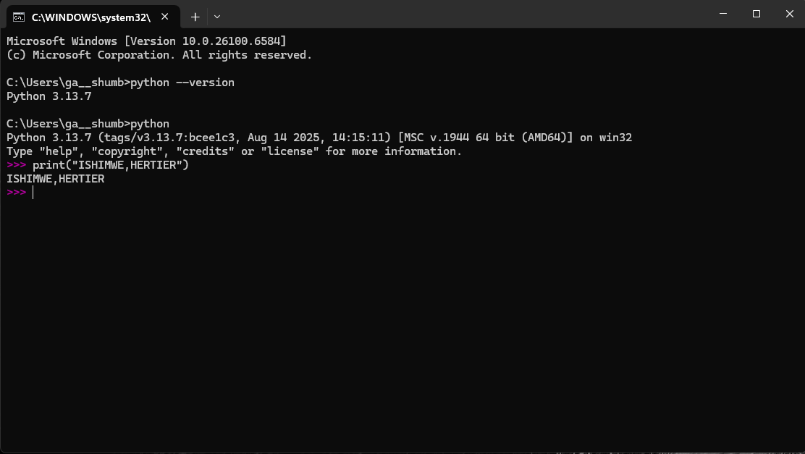

Project testing
Username and password with age verification project
- We opened our python and wrote the following codes.
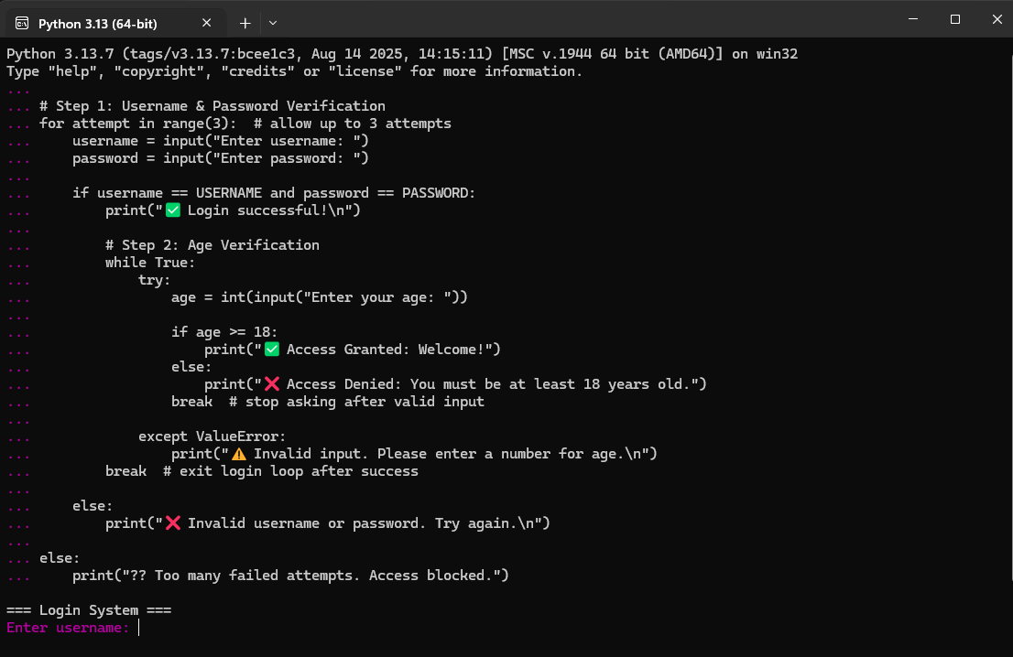
- And then our project was running like this.
- Username and Password verification was successful
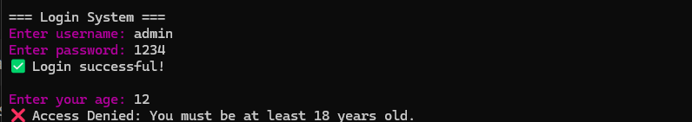
- Age verification when was less than 18 it was denied
- When age was greater than 18 access was granted

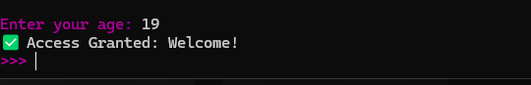

THANK YOU TO YOU ALL!!!

